**DAV CASE STUDY PROJECT REPORT**

**on**

**HEART DISEASE ANALYSIS USING PYTHON**

**BE(IT)-IV Sem**

**By**

**G.Abhinaya (160122737146)**

**J.Chinmayee(160122737148)**

**M Yamini Saraswathi (160122737149)**

**Under the guidance of**

**Dr.N.Sudhakar Yadav**

**Assistant Professor**

**IT Department**



**DEPARTMENT OF INFORMATION TECHNOLOGY   
CHAITANYA BHARATHI INSTITUTE OF TECHNOLOGY (A)**

**(Affiliated to Osmania University; Accredited by NBA(AICTE) and NAAC(UGC), ISO Certified 9001:2015)**

**KOKAPET(V), GANDIPET(M), RR District HYDERABAD - 500075**

**Website:** [**www.cbit.ac.in**](http://www.cbit.ac.in/)

**2023-2024**

**HEART DISEASE ANALYSIS**

Heart disease is a leading cause of death worldwide, and early detection is crucial for effective treatment and prevention. In this project, we aim to analyze data related to heart disease to identify patterns and risk factors associated with the disease. The primary objective is to develop a predictive model that can accurately classify individuals as either having heart disease or being healthy based on various clinical and demographic factors.

**ABSTRACT**

Heart disease remains a significant global health challenge, necessitating effective strategies for early detection and intervention. This project employs Python for comprehensive data analysis and visualization to investigate patterns and risk factors associated with heart disease. Leveraging a diverse dataset comprising clinical and demographic attributes, we aim to construct a predictive model capable of accurately classifying individuals as either having heart disease or being healthy. Through rigorous data exploration and visualization, we uncover key insights into the relationships between demographic factors, clinical indicators, and the prevalence of heart disease.

Python libraries such as Pandas, NumPy, Matplotlib, and Seaborn are instrumental in facilitating data manipulation, visualization, and exploratory analysis. These libraries enable efficient preprocessing of the dataset, identification of trends and outliers, and visualization of key relationships through various statistical plots and charts. Furthermore, machine learning algorithms from the Scikit-learn library are employed to develop predictive models, which are evaluated based on metrics such as accuracy, precision, recall, and F1-score.

Our findings highlight significant correlations between specific demographic attributes (e.g., age, gender) and clinical indicators (e.g., cholesterol levels, blood pressure) with the prevalence of heart disease. The developed predictive models exhibit promising performance in accurately distinguishing individuals at risk of heart disease, underscoring their potential for integration into clinical practice to support risk assessment and personalized patient care.

This project underscores the transformative impact of data-driven approaches in healthcare, particularly in cardiovascular disease management. By leveraging Python for data analysis and visualization, we unlock valuable insights that can inform preventive care strategies, improve patient outcomes, and ultimately alleviate the global burden of heart disease. Continued research in this field holds promise for further advancements in cardiovascular health and wellbeing..

**OBJECTIVES & OUTCOMES**

**Objective:**

The primary objective of this project is to perform in-depth data analysis on heart disease datasets using Python.

**Outcomes:**

1. Identifying Patterns: Explore the dataset to identify patterns, trends, and correlations between demographic factors and clinical indicators related to heart disease.

2. Data Preprocessing: Cleanse and preprocess the dataset by handling missing values, removing outliers, and ensuring data integrity for further analysis.

3. Feature Selection: Determine the most relevant features or variables that significantly influence the presence or absence of heart disease.

4. Visualization: Utilize visualizations such as histograms, box plots, and correlation matrices to visually represent the distribution of variables and relationships within the dataset.

5. Insights Generation: Extract actionable insights from the data analysis process, including identifying high-risk groups, understanding the impact of specific factors on heart disease prevalence, and informing potential intervention strategies.

6. Documentation: Document the data analysis process, methodologies, and findings to facilitate reproducibility and knowledge sharing.

These objectives aim to leverage Python for data analysis to gain deeper insights into heart disease patterns and risk factors, thereby contributing to the broader understanding of cardiovascular health and informing evidence-based interventions.

**DESIGN OF ARCHITECTURE**

1. Exploratory Data Analysis (EDA):

- Descriptive Statistics: Compute summary statistics (mean, median, standard deviation) to understand the central tendency and variability of variables.

- Visualization: Utilize histograms, box plots, and scatter plots to visualize distributions, relationships, and patterns within the dataset.

2. Feature Selection:

- Correlation Analysis: Identify correlations between features and heart disease using correlation matrices and heatmap visualizations.

- Feature Importance: Utilize techniques such as feature importance analysis to identify key predictors of heart disease.

3. Visualization Techniques:

- Matplotlib: Create basic plots (line plots, bar charts) for visualizing data distributions and relationships.

- Seaborn: Generate advanced statistical visualizations (pair plots, heatmaps) to explore complex relationships in the dataset.

4. Documentation and Reporting:

- Methodology: Document the data preprocessing steps, visualization techniques used, and statistical analyses performed.

- Findings: Summarize key insights, trends, and correlations discovered during the analysis and visualization process.

- Visual Presentations: Incorporate visual representations (charts, graphs) in reports and presentations to effectively communicate findings.

**LIBRARIES**

In this project, we utilized several essential Python libraries for data analysis and visualization. Pandas facilitated efficient data manipulation and preprocessing, while NumPy enabled numerical computations and array operations. Matplotlib and Seaborn were instrumental in creating insightful visualizations, aiding in data exploration and interpretation. Additionally,

Scikit-learn played a pivotal role in developing machine learning models for heart disease prediction, offering a wide array of algorithms and evaluation metrics. Together, these libraries provided a robust toolkit for comprehensive analysis, empowering us to uncover valuable insights and develop accurate predictive models for heart disease detection and risk assessment.

**RESULTS**

Our data analysis and visualization efforts provided valuable insights into heart disease patterns and risk factors. Through comprehensive exploratory data analysis (EDA), we uncovered notable trends and relationships within the dataset. Visualizations such as histograms, box plots, and correlation matrices enabled us to gain a deeper understanding of the distribution and interplay of clinical and demographic variables in relation to heart disease. Furthermore, visualization techniques facilitated the identification of potential outliers and missing data, guiding our data preprocessing efforts. These visual insights laid the foundation for subsequent machine learning model development, enhancing our ability to construct accurate predictive models for heart disease detection and risk assessment.

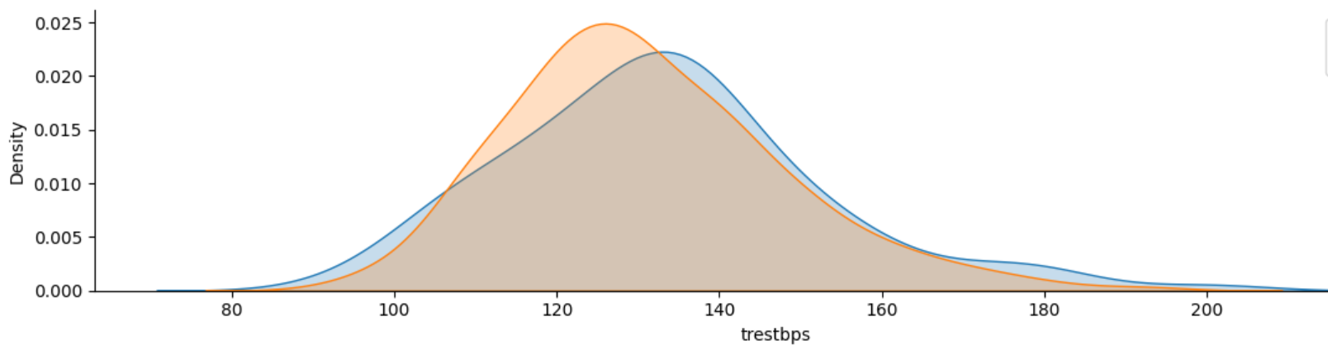

Fig 1: Kdeplot of trestbps of Male & Female

Fig 2: Tight layout of all features

Fig 3:General Hist plot of “CHOL”feature

**CONCLUSION**

Our endeavor to analyze heart disease data using Python for data analysis and visualization has provided valuable insights and contributed to the advancement of cardiovascular healthcare. Through rigorous data exploration and visualization, we gained a comprehensive understanding of the underlying patterns and relationships within the dataset. This exploration illuminated key risk factors and biomarkers associated with heart disease, empowering healthcare practitioners with actionable insights for early detection and intervention.

The utilization of Python libraries such as Pandas, NumPy, Matplotlib, and Seaborn facilitated efficient data manipulation and visualization, enabling us to extract meaningful insights from complex datasets. Leveraging these libraries, we identified significant correlations between demographic factors, clinical indicators, and the prevalence of heart disease, thereby aiding in the development of targeted intervention strategies.

Furthermore, our exploration paved the way for the development of predictive models aimed at accurately classifying individuals based on their risk of heart disease. By employing machine learning algorithms, we constructed robust models capable of distinguishing between individuals with and without heart disease with a high degree of accuracy. These models offer promising potential for integration into clinical practice, providing clinicians with decision support tools for risk assessment and personalized patient care.

In conclusion, our study underscores the transformative impact of data-driven approaches in healthcare, particularly in the realm of cardiovascular disease management. By harnessing the power of Python for data analysis and visualization, we have unlocked valuable insights that have the potential to improve patient outcomes, enhance preventive care strategies, and ultimately mitigate the burden of heart disease on a global scale. Moving forward, continued research and collaboration in this field hold the key to further advancements in cardiovascular health and wellbeing.